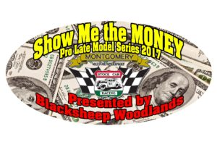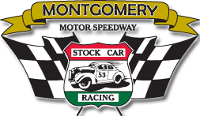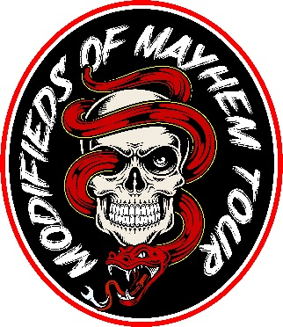

**To all Racers, Crewmembers, Car Owners and Fans,**

Thank you all for supporting Montgomery Motor Speedway in 2017, it’s that time of year for all to celebrate our Racing Season. The 2017 Awards Dinner will be held Sunday January 21, 2018 at the ***Montgomery Marriot Prattville Hotel & Conference Center*** at Capitol Hill 2500 Legends Circle, Prattville, Al 36066

Tickets are $30 per person in Advance ……$35 at the door

Schedule of Events

5pm Meet and greet

6pm Dinner served

7pm Awards Ceremony

***Menu***: Capital Hill Chicken topped with Creamy Herb Jus / Garlic Mashed Potatoes Green Beans / Fresh Baked Rolls / Coffee, Tea and Water/ Dessert

We encourage everyone to attend. We will have door prizes and giveaways

All drivers in attendance will be entered into the HANS Device giveaway.

We will recognize the top 5 in each Montgomery Motor Speedway Division and the top 3 in the **Modifieds of Mayhem** Tour.

Driver or A Representative must attend to receive Awards and Prizes.

Please Fill out form Below and Remit Payment to

Montgomery Motor Speedway 480 Booth Rd. Montgomery, Al 36108

-------------------------------------------------------------------------------------------------------------------------------------

NAME_____________________________________________x $30_________

NAME_____________________________________________x $30_________

NAME_____________________________________________x $30_________

NAME_____________________________________________x $30_________

NAME_____________________________________________x $30_________

NAME ____________________________________________ x $30_________

Please use back for more names if needed

**Total $**